

4.7: Developing if Statements in Python

We are going to gradually build up our program so that it allows you to enter a number, and it will tell you whether it is odd or even, and finally, if it is divisible by 3. Throughout this example we will also be using a main function to test our function.

Let’s start by creating a function which tells us whether a number (entered as a parameter) is odd or even - you should be able to do this after the class last week, but as a recap, enter the following code:

def divisor_test(number):

For this example, we will be using the mod function (%), which finds the remainder of a number divided by another.

In your function, enter the following code:

if(int(number) % 2 == 0):

print(number + " is even")

We are now going to write a main function, which tells the user to enter a number, then runs the divisor_test() function to show whether the entered number is even:

def main():

number_to_check = input(“Enter a number: ”)

divisor_test(number_to_check)

Don’t forget to run your main function within your file. Your final code should look as follows:

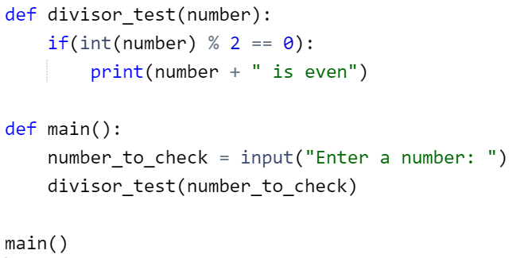

This main function will remain the same throughout the example, so you should only need to change your divisor_test() function.

You should get the following output when the main function is run:



**Your Turn 1:**

Write a program which asks the user to enter the day of the week and displays the following message if the day is Friday:

“Payday! :)”

Don’t forget to make use of functions!

*(Note: for this program, we are assuming that the person gets paid each week on a Friday)*

Extension for people who finish quickly – you will have probably programmed your system in such a way that it is case sensitive. How might you overcome this issue?